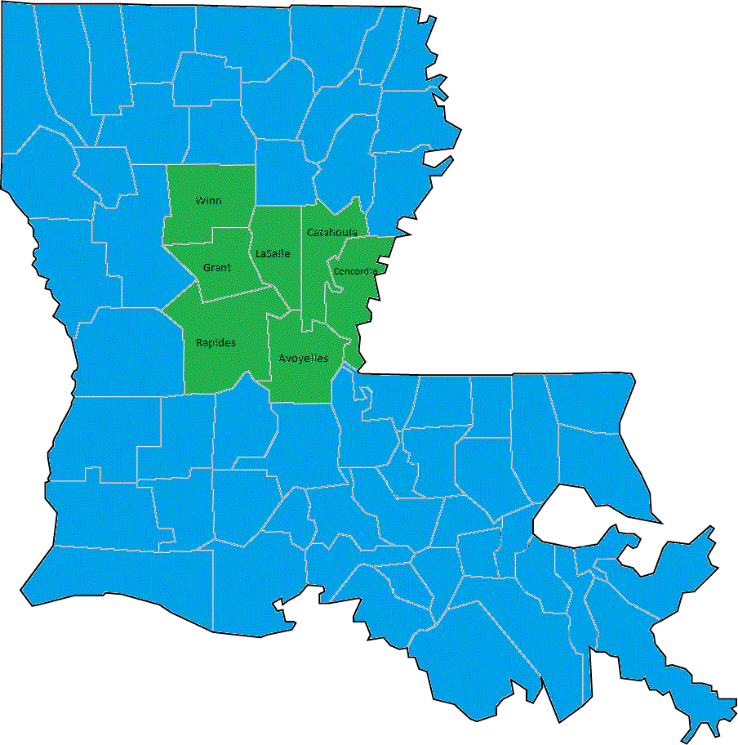  Region six Workforce Development board partnership  Avoyelles, Catahoula, Concordia, Grant, LaSalle, Rapides, and Winn | WIOA REgional Plan  2020-2024  TWO-YEAR MODIFICATION  

Workforce Innovation and Opportunity Act (WIOA)
Regional Plan for Workforce Development Boards 60 & 61

Regional Workforce Development Board Partnership Strategic Vision
The two Workforce Development Areas in Region Six share the same vision that incorporates a regional workforce development system aligned with the governor’s statewide vision to provide pathways for all Louisianans to prepare for and secure high-demand occupations that pay family-sustaining wages by creating an environment in which our businesses can grow, and our people can prosper. The Region’s Workforce Development Boards (WDB) work together to strategically invest in high growth/high wage industries, work closely with all One-Stop partners and other entities that can contribute to the development of the workforce and be proactive.
Region Six WDB Partnership is a strong advocate of the deep connection between workforce development and economic development goals for attracting, retaining, and growing business and industry. The Region Six WDB Partnership seeks to positively contribute to economic development goals through our business services strategies, recruitment processes, and strategic business programs that will benefit the businesses of the region. The Region serves to foster connections between businesses and the educational community to identify and close skills gaps in order that the current and future workforce needs of businesses are addressed.
The Region Six WDB Partnership utilizes the strength of diversity of the key stakeholders that serve on each Workforce Development Board, the broad industry and educational partnerships that extend beyond the Boards, and a strong presence in the business community to continuously identify the workforce challenges, develop innovative strategies and leverage solutions.

As partners, we have continued the development of regional initiatives aligned with the statewide vision through collaborative regional endeavors to address the changing environment as impacted by changing industries, COVID related mass lay-offs, as well as adjusting to the technological advances impacting many industry sectors. This work includes many initiatives, such as regional collaboration to provide customized training, adoption of modern technology to better connect to the community residents.

Regional Workforce Development Priorities

- To provide relevant and value-added services to businesses and jobseekers
- To prepare the workforce to meet the current and future needs of businesses
- To serve as a center for workforce innovation
- To promote effective regional alignment, collaboration, and partnerships

- The Region believes that setting these overarching priorities will lead to actualizing the governor’s statewide vision of “Putting Louisiana First” by creating an environment in which our businesses can grow, and our people can prosper. Ensuring that the services provided to businesses and job seekers are relevant and value-added and will promote a healthier business and workforce environment. Continually assessing the needs of businesses and adapting our strategies to meet those needs allowing for a workforce system that businesses require. We seek new and innovative ways for service delivery and promote effective collaboration and partnership allowing for the system to develop new best practices that can serve as a model for other areas of the state. It also provides greater chances for attaining leveraged funding through various grant opportunities.

CHAPTER 1: ECONOMIC AND WORKFORCE ANALYSIS – REGIONAL COMPONENT
The Cenla Region is defined as the seven parishes that make up the 6th Regional Labor Market Area (RLMA 6): Avoyelles, Catahoula, Concordia, Grant, LaSalle, Rapides, and Winn. There were 62,400 non-farm employees in the region in 2022. While there are some notably large manufacturing firms in this MSA, the manufacturing and mining sectors are small compared to other MSAs in Louisiana.
- Some large firms add an important private sector base to this MSA. The 1,200-person Procter & Gamble is the largest manufacturer in the region, and nearby PlastiPak (nearly 300 jobs), makes the containers to hold P&G’s products. Equivalent in employment size to P&G, utility company Cleco is headquartered in Pineville and is an important economic driver for the community. Crest Industries is a 700-800-person conglomerate that is engineering focused, but all has a major subsidiary manufacturing equipment for the utility industry. Union Tank Car (approximately 350 employees) manufactures railroad tank cars to primarily transport chemical products. Alexandria has an incredibly significant government base (23% of its employment), second only to Hammond in its dependency on this sector. Pinecrest Support and Services Center, which provides care for the mentally disabled and Central State Hospital---a facility for the mentally ill---are both located in the MSA and between them employ about 1,800 people. Roy O. Martin employs just over 900 at two wood processing sites a couple of miles outside of Rapides Parish to the north and south, with the headquarters located in Alexandria. The Rapides Parish School Board employs just under 800 people. As in most areas, Healthcare providers continue to employ an exceptionally large segment of the population. In Region 6, the largest being Rapides Regional Medical Center with 1150 employees and CHRISTUS St. Frances Cabrini employing 1600.
- YellaWood is spending $22.5 million to expand its Avoyelles Parish plant and add 58 jobs to its 75-person workforce. This plant should be completed toward the end of 2023.
- In Avoyelles Parish, Paragon Casino spent $100 million on a new addition.
- Syrah Resources has its $176 million Phase II of its graphite facility underway in Concordia Parish. A manufacturer of natural graphite used in batteries, Syrah should complete Phase II in late 2023 and increase its employment from 25 to 102. The firm already has a definitive feasibility study underway for a Phase III that would jump its output from 11,400 tons to 45,000 tons and increase employment to 221. A final investment decision (FID) is expected in 2023.
- Rural Louisiana did not bounce back fully from the hit of the Great Recession. In the two years of 2011-12 the region added back about 5,000 jobs, still well below the pre-recession peak in 2006. There were several nice economic wins for the rural parishes over these two years, including. In Urania, German Pellets began construction on the world’s largest wood pellets manufacturing plant (+150 jobs). Universal Plant Services built a $3.9 million, 95-person welding, fabrication, and equipment overhaul and repair plant in LaSalle Parish.
- Back to 1991: the 2014-19 Decline The period from 2014 to 2019 were recession-free years at the national level, but not so for rural Louisiana. 29 parishes lost a shattering 8% of their jobs or 18,900 jobs in total. There was only one slight growth year among these six years. This decline was partly driven by problems at individual firms across these parishes. For example: • German Pellets plant in LaSalle Parish went into bankruptcy. Fruit-of-the-Loom closed its Vidalia plant (-167 jobs).

Region 6 is comprised of two (2) Workforce Development Areas - #60 and #61 that cover the geographical area of seven (7) parishes with a total population, in 2022, of 245,397, an overall reduction of 1.01% since 2020. This region is predominately rural, bordered to the north and south by rural parishes in other regions. The eastern edge of the region borders Natchez, Mississippi while the western edge borders Vernon Parish. Table 1 represents the breakdown in parish population as well as the total for RLMA 6.

PARISH | 2020 Population | 2022 Population | 2020-2022 Change
AVOYELLES | 39,690 | 38,751 | -939 | -1.02
CATAHOULA | 8,903 | 8,566 | -337 | -1.04
CONCORDIA | 18,681 | 18,116 | -565 | -1.03
GRANT | 22,163 | 22,000 | -163 | -1.01
LASALLE | 14,797 | 14,729 | -68 | -1.00
RAPIDES | 128,748 | 130,030 | 1,282 | -0.99
WINN | 13,755 | 13,205 | -550 | -1.04
Total | 246,737 | 245,397 | -1,340 | -1.01
Source: US Census Bureau

According to estimates made by the Federal Bureau of Economic Analysis, economic activity in the Alexandria Metropolitan Statistical Area (MSA) contributed 3.61% to Louisiana’s GDP in 2021, which was an increase .23% from 2019.

Table 1. Real Gross Domestic Product, by County, 2018–2021
 | Real gross domestic product |  |  |  |  | Percent change from preceding period
 | Thousands of chained (2012) dollars |  |  |  | Rank in state | Percent change |  |  | Rank in state
 | 2018 | 2019 | 2020 | 2021 | 2021 | 2019 | 2020 | 2021 | 2021
Louisiana | 237,298,288 | 237,044,596 | 218,421,686 | 221,152,704 | -- | -0.1 | -7.9 | 1.3 | --
Avoyelles | 864,920 | 844,574 | 815,911 | 814,271 | 41 | -2.4 | -3.4 | -0.2 | 40
Catahoula | 165,382 | 175,545 | 175,892 | 173,552 | 62 | 6.1 | 0.2 | -1.3 | 47
Concordia | 540,639 | 549,545 | 530,619 | 544,685 | 48 | 1.6 | -3.4 | 2.7 | 23
Grant | 341,087 | 328,022 | 338,495 | 341,243 | 58 | -3.8 | 3.2 | 0.8 | 31
LaSalle | 472,357 | 490,676 | 462,233 | 447,934 | 53 | 3.9 | -5.8 | -3.1 | 49
Rapides | 5,204,089 | 5,199,648 | 5,069,677 | 5,205,741 | 11 | -0.1 | -2.5 | 2.7 | 22
Winn | 437,904 | 421,043 | 451,305 | 451,732 | 52 | -3.9 | 7.2 | 0.1 | 37

Annual Contributions to GDP Change by Industry 2021
Industry | Percentage Points
  Transportation and Utilities | 1.67
  Utilities | 1.39
  Professional and Business Services | 0.72
  Administrative | 0.7
  Accommodation | 0.37
  Trade | 0.36
  Construction | 0.35
  Transportation and Warehousing | 0.28
  Wholesale Trade | 0.26
  1.67
  1.39
  0.72
  0.7
  0.37
  0.36
  0.35
  0.28
  0.26
Source: U.S. Bureau of Economic Analysis

EXISTING DEMAND AND INDUSTRY SECTORS AND OCCUPATIONS
Provide an analysis of the industries and occupations for which there is existing demand.

The data contained in Table 2 depict changes in employment for two-digit North American Classification System (NAICS) sectors within Region 6 in comparing two points in time: 2016 and 2026 and give some idea of the existing workforce demand for each sector. Table 2 shows that, over this ten-year period, 16 of the 20, two-digit NAICS sectors, in Region 6 saw an increase in employment. While the increase, overall, is not a sizable percentage growth, the employment projections show a steady future economic foundation in Region 6. Health Care & Social Assistance reflects a forecast 9% increase making it the second largest percentage sector increase and the largest number of jobs totaling 1,689.

In 2020, the Alexandria MSA is unlikely to face significant negative changes and may improve noticeably in Mining and other sectors, if interest and activity increase in Austin Chalk, an oil play that runs right through the Alexandria MSA. (The Louisiana Economic Outlook, 2020)

Table 2: Changes in Average Employment for Two Digit NAICS Sectors 2016-2026
 | 2016 | 2026 | Change | % of Jobs Lost | % of Jobs Gained
TOTAL EMPLOYMENT | 96,893 | 101,795 | 4,902 | ------- | 5.1%
Agriculture, Forestry, Fishing & Hunting | 3,495 | 3,445 | -50 | -1.4%
Mining | 585 | 707 | 122 |  | 20.9%
Utilities | 444 | 456 | 12 |  | 2.7%
Construction | 4,274 | 4,619 | 345 |  | 8.1%
Manufacturing | 6,246 | 6,227 | -19 | -0.3%
Wholesale Trade | 2,701 | 2,864 | 163 |  | 6%
Retail Trade | 11,720 | 12,134 | 414 |  | 3.5%
Transportation & Warehousing | 2,460 | 2,501 | 41 |  | 1.7%
Information | 712 | 645 | -67 | -9.4%
Finance & Insurance | 2,558 | 2,584 | 26 |  | 1.0%
Real Estate, Rental, Leasing | 710 | 771 | 61 |  | 8.6%
Professional & Technical Services | 2,616 | 2,765 | 149 |  | 5.7%
Management of Companies & Enterprises | 741 | 800 | 59 |  | 8%
Administrative & Waste Services | 4,308 | 4,624 | 316 |  | 7.3%
Educational Services | 8,071 | 8,664 | 593 |  | 7.3%
Health Care & Social Assistance | 18,689 | 20,378 | 1,689 |  | 9%
Arts, Entertainment, & Recreation | 646 | 692 | 46 |  | 7.1%
Accommodation & Food Services | 6,635 | 7,139 | 504 |  | 7.6%
Other Services | 8,023 | 8,021 | -2 | 0.0%
Public Administration | 11,259 | 11,759 | 500 |  | 4.4%
Source: U.S. Bureau of Economic Analysis
Jobs lost – 138 Jobs gained – 4,902 Net change – 4,764

It should be kept in mind that the data in Table 2 shows employment in the aggregate for each of the 20 two-digit NAICS sectors. It is always possible that some employers within a sector may be adding employees while some employers within a sector may not be hiring or even laying off employees.

The four industry drivers with occupations paying higher wages and with the greatest number of employees for the central Louisiana region have been Healthcare, Manufacturing, Construction and Administrative and Waste services. There are a large number of individuals working in the Retail Trade (NAICS 44-45). However, since the educational requirements and wage-earning potential for this sector is low, this sector was not selected as an industry driver.

The Louisiana Workforce Commission provides short-term (2 year) employment projections by industry (2-digit NAICS sectors) for Region 6 as shown in Table 3.

Under the assumption that short-term projections would more likely be an indicator of emerging trends in employment growth and the occupations associated with particular industry sectors, the short-term (2016 – 2019) projections in Table 3 contain a number of contradictions when compared with the changes in employment that appear to have actually taken place for some sectors as represented in Table 2.
Table 3 shows the industry subsectors expected to achieve the highest growth in the short-term (through 2019) and long-term (through 2026). Using the NAICS codes, those industry subsectors with the highest expected long-term growth are Mining (20.9%), Transportation and Warehousing (14.1%), and HealthCare and Social Assistance (9%).

Table 3: Projected Short-Term & Long –Term Employment Growth – Region 6
Industry Sector | Employment Change 2016 – 2019 | Employment Growth Rate 2016-2019 | Employment Change 2016 - 2026 | Employment Growth Rate 2016-2026
Agriculture, Fishing, Forestry, and Hunting | +8 | .2% | -50 | -1.4%
Mining | +56 | 9.6% | +122 | 20.9%
Utilities | -11 | -2.5% | 12 | 2.7%
Construction | 120 | 2.8% | 345 | 8.1%
Manufacturing | -560 | -9.0% | -19 | -2.8%
Wholesale Trade | -16 | -.06% | 163 | 6.0%
Retail Trade | -198 | -1.7% | 414 | 3.5%
Transportation and Warehousing | 62 | 2.5% | 346 | 14.1%
Information | -12 | -1.7% | -67 | -9.4%
Finance and Insurance | -3 | -.1% | 26 | 1.0%
Real Estate and Rental and Leasing | -25 | -3.5% | 61 | 8.6%
Professional, Scientific and Technical Services | 1 | 0.0% | 149 | 5.7%
Management of Companies and Enterprises | -34 | -4.6% | 59 | 8.0%
Administrative and Waste Services | -359 | -8.3% | 316 | 7.3%
Educational Services | +219 | 2.7% | 593 | 7.3%
Health Care and Social Assistance | 799 | 4.3% | 1,689 | 9.0%
Arts, Entertainment and Recreation | 12 | 1.9% | 46 | 7.1%
Accommodation and Food Service | 240 | 3.6% | 504 | 7.6%
Other Services, Except Public Administration | -493 | -6.1% | -2 | 0.0%
Government | 260 | 2.3% | 500 | 4.4%
Source: Louisiana Workforce Commission LMI data

Table 4 shows the top twelve (12) high-demand occupations by the number of annual openings and the star rating. The industry sectors associated with these occupations are Healthcare & Social Assistance, Educational Services, Construction, and Finance and Insurance. Registered Nurses and Licensed Practical/Vocational Nurses continue to be high demand occupations in RLMA 6. Demand for nurses is expected to continue to increase, as this area has growing populations of senior citizens and young people, both of whom are the primary customers of health care and social assistance and retiring baby-boomers.

Table 4: Top 12 High Demand Occupations by Employment through 2026
Star Rating | Occ. Code | Occupational Title | Annual Total Openings | 2019 RLMA 6 Annual Average Wage | 2019 State Annual Average Wage
 | 29-1141 | Registered Nurses | 370 | $63,153 | $63,563
 | 25-2021 | Elementary School Teachers, Except Special Education | 120 | $42,709 | $48,307
 | 11-1021 | General and Operations Managers | 110 | $91,931 | $115,059
 | 29-2052 | Pharmacy Technicians | 70 | $34,441 | $32,700
 | 29-2061 | Licensed Practical and Licensed Vocational Nurses | 40 | $38,923 | $39,481
 | 13-1199 | Business Operations Specialists, All Other | 90 | $58,336 | $60.431
 | 25-2031 | Secondary School Teachers, Except Special and Career/Technical Education | 70 | $45,044 | $51,806
 | 29-1171 | Nurse Practitioners | 30 | $142,953 | $105,336
 | 29-1123 | Physical Therapists | 30 | $108,980 | $159,889
 | 11-3031 | Financial Managers | 30 | $106,946 | $129,849
 | 47-2152 | Plumbers, Pipefitters, and Steamfitters | 30 | $49,852 | $54,935
 | 11-9111 | Medical and Health Services Managers | 20 | $99,861 | $100,705
Source: LWC Regional Labor Market Data (RLMA) 6, LWC – Office of Occupational Services

Targeted Industries and High Impact Industry Clusters

Figure 1 provides projections on the industries expected to experience the greatest employment growth by 2026 which corroborates the data in Table 4. The highest growth occupations according to these projections will be in the Health Care and Social Assistance, Educational Services and Construction industries. The aging of the baby boom generation will necessitate more people working to care for this segment of the population.

Figure 1: 2016-2026 (Long-term) Industry Projections for RMLA 6, Two-Digit NAICS
Long-term projection data also points to the industries likely to have the largest absolute employment growth over the projected period. The highest numbers in employment growth will come from Industry Sectors such as Health Care and Social Assistance, Construction, Educational Services, Mining, and other services referenced in Table 5.

Table 5: 2026 Industry Projections for RMLA 6, Highest Forecasted Growth

Industry Sectors | Employment Growth | Growth Percent
Healthcare and Social Assistance | 1,689 | 9.0%
Mining | 122 | 20.9%
Real Estate & Rental and Leasing | 61 | 8.1%
Construction | 345 | 8.1%
Educational Services | 593 | 7.3%
Accommodation and Food Services | 504 | 7.6%
Administrative and Waste Services | 316 | 7.3%
Source: LWC Regional Labor Market Data (RLMA) 6, LWC – Office of Occupational Services

Table 6 reveals the occupations expected to have the greatest growth in percentage. The demand is also demonstrated by the assignment of stars through LWC’s Star Rating System with three, four and five stars denoting in-demand occupations.

Table 6: 2026 Occupational Projections for RMLA 6, Highest Forecasted Growth Jobs
Star  Rating | Occ.  Code | Occupational Title | 10 Year %  Job Growth
 | 11-3021 | Computer and Information Systems Managers | 20.00%
 | 11-3031 | Financial Managers | 13.04%
 | 11-3121 | Human Resources Managers | 16.67%
 | 11-9032 | Education Administrators, Elementary and Secondary School | 7.41%
 | 11-9111 | Medical and Health Services Managers | 7.69%
 | 11-9151 | Social and Community Service Managers | 9.09%
 | 11-1021 | General and Operations Managers | 8.40%
 | 13-1161 | Market Research Analysts and Marketing Specialists | 30.00%
 | 13-2011 | Accountants and Auditors | 7.50%
 | 15-1141 | Database Administrators | 33.33%
 | 15-1142 | Network and Computer Systems Administrators | 14.29%
 | 15-1151 | Computer User Support Specialists | 16.67%
 | 21-1021 | Child, Family, and School Social Workers | 20.00%
 | 21-1022 | Healthcare Social Workers | 9.09%
 | 21-1094 | Community Health Workers | 25.00%
 | 25-2021 | Elementary School Teachers, Except Special Education | 8.11%
 | 25-2031 | Secondary School Teachers, Except Special and Career/Technical Education | 8.33%
 | 25-2051 | Special Education Teachers, Preschool | 10.00%
 | 27-3031 | Public Relations Specialists | 20.00%
 | 29-1051 | Pharmacists | 7.41%
 | 29-1123 | Physical Therapists | 16.67%
 | 29-1127 | Speech-Language Pathologists | 9.09%
 | 29-1141 | Registered Nurses | 11.97%
 | 29-1171 | Nurse Practitioners | 25.00%
 | 29-2052 | Pharmacy Technicians | 16.67%

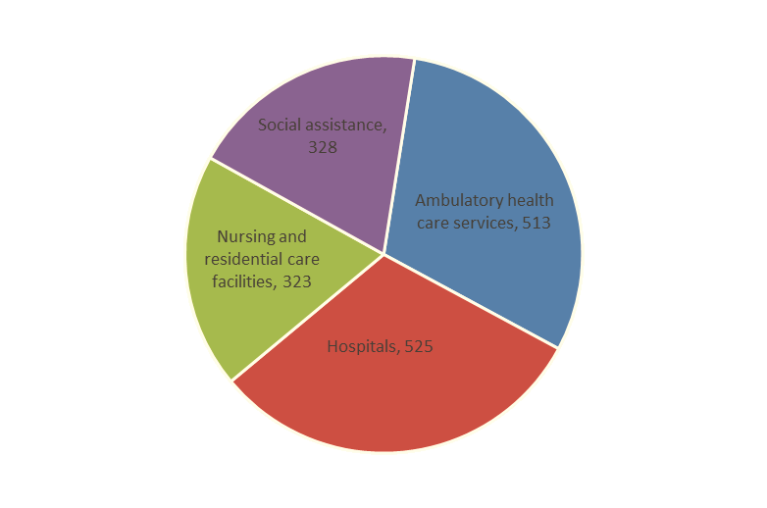
Figure 2: Projected Employment through 2026 in the Health Care and Social Assistance Industry
Quick Facts
Fueled by the aging of the baby boomers, the Health Care and Social Assistance Industry is projected to grow by 1,689 between 2016 and 2026. This growth is broken down further into subsectors within the Ambulatory health services, Hospitals, Nursing and residential care facilities, and social assistance industries. Nearly three quarters of the projected growth is attributable to Hospital workers and Ambulatory Care Services, 61.5 percent. The number of job vacancies in this sector also shows strong demand for workers in the Health Services Sector now and in the future.

EMPLOYERS’ EMPLOYMENT NEEDS

As evidenced by Table 7, 6.51% of the current job vacancies in Region 6 listed on the LWC’s labor exchange service system, HiRE, have requirements of at least a high school diploma or equivalent (HiSET). The majority of employers are not specifying their educational needs on the job openings (78.18%). However, with the large demand in the Health Care industry, it is understood that the larger part of those positions would require at least an associate degree of a Vocational/Technical diploma/degree.

Table 7: Education Requirements of Job Vacancies, Region 6 (as of 4/23/2023)
Rank | Education Level | # Job Openings | % of Job Openings | # of Potential Candidates | % of Potential Candidates
1 | No Minimum Education Requirement | 287 | 7.11% | 0 | N/A
2 | Less than High School | 0 | N/A | 394 | 5.69%
3 | High School Diploma or Equivalent | 263 | 6.51% | 2,818 | 40.66%
4 | 1 Year of College or a Technical or Vocational School | 5 | 0.12% | 627 | 9.05%
5 | 2 Years of College or a Technical or Vocational School | 0 | N/A | 500 | 7.21%
6 | 3 Years of College or a Technical or Vocational School | 0 | N/A | 233 | 3.36%
7 | Vocational School Certificate | 51 | 1.26% | 668 | 9.64%
8 | Associate degree | 138 | 3.42% | 616 | 8.89%
9 | Bachelor's Degree | 83 | 2.06% | 793 | 11.44%
10 | Master's Degree | 20 | 0.50% | 236 | 3.41%
11 | Doctorate Degree | 9 | 0.22% | 30 | 0.43%
12 | Specialized Degree (e.g., MD, DDS) | 25 | 0.62% | 14 | 0.20%
13 | Not Specified | 3,156 | 78.18% | 2 | 0.03%

Of the advertised job openings on Louisiana Workforce Commission labor exchange service, Table 8 shows 88.67 % of employers in Region 6 are looking for candidates with 1 - 5 years of experience. Only 13.67% of the potential candidates had 1 - 5 years of experience. However, 66.42% of potential candidates had 5 - 10+ years of experience! Clearly, there are other mitigating factors (e.g., there are more available experienced workers than job/industry openings, recognized credentials, lots of experience in a declining industry / occupation) which are barriers preventing these more experienced workers from achieving employment.
Table 8 – Work Experience, Region 6
Experience  Requirements | # of Job Openings | Percentage of Job Openings | Potential Candidates | Percentage of Potential Candidates
Entry Level | 411 | 10.18% | 0 | N/A
Less than 1 year | 100 | 2.48% | 1383 | 19.95%
1 Year to 2 Years | 3,416 | 84.62% | 282 | 4.07%
2 Years to 5 Years | 104 | 2.58% | 662 | 9.55%
5 Years to 10 Years | 6 | 0.15% | 936 | 13.89%
More than 10 Years | 0 | NA | 3,641 | 52.53%

The top advertised certifications needed by employers in Region 6, as indicated in their job openings, are found in Table 9.

Table 9 – Top Advertised Job Certification, Region 6
Advertised Certification Group | Advertised Certification Sub-Category | Job Opening Match Count
American Heart Association (AHA) CPR & First Aid Certifications | Nursing | 3045
Nursing Credentials and Certifications | Nursing | 2057
Commercial Driver’s License (CDL) | Ground Transportation | 267
Social Worker Credentials & Certification | Social and Human Services | 210
National Board for Respiratory Care (NBRC) | Medical Treatment and Therapy | 177
American Academy of Neurology (AAN) Designations | Medical Professional | 75
American Organization for Nursing Leadership (AONL) Certification | Nursing | 75
American Association of Medical Assistants (AAMA) Certifications | Medical Professional | 54
American Institute of CPAs (AICPA) Certifications | Financial Specialists | 51
State Licensed Counselors | Counseling | 46

Table 10 clearly shows that most businesses in Region 6 are small businesses. About 98% of the employees in the region work in establishments with less than 100 employees according to the 2021 County Business Patterns from the U.S. Census Bureau. Only 7 businesses had more than 500 employees which is the Small Business Administration’s official cut off for a “small business”. Small businesses are vital to the entire Region 6 economy.

Table 10: Region 6 Employers by Size
Number  of Employees | LWDA 60 | LWDA 61
Number  of Employees | Number of Establishments | Number of Establishments
1-4 | 1187 | 1,520
5-9 | 392 | 682
10-19 | 234 | 471
20-49 | 137 | 306
50-99 | 36 | 83
100-249 | 29 | 51
250-499 | 4 | 14
500-999 | 0 | 4
1,000+ | 0 | 3
Source: County Business Patterns, Release date 4/27/2023.

Workforce Analysis

The Unified or Combined Regional Plan must include an analysis of the current workforce, including individuals with barriers to employment as defined in Section 3 of WIOA. This population must include individuals with disabilities among other groups in the region. This includes individuals with disabilities among other groups in the State and across the region as identified by the State. This includes –

Employment and Unemployment.

Include an analysis of current employment and unemployment data, including labor force participation rates, and trends in the Region / Local area.

Labor Market Trends

Provide an analysis of key labor market trends, including across existing industries and occupations.
Figure 3 demonstrates the median income for Region 6 households by parish. Overall, Region 6 median household income decreased by 3.8% and increased by 55.5% in 2019-2020.

Figure 3: Regional Household Median Income Distribution, Region 6 by Parish

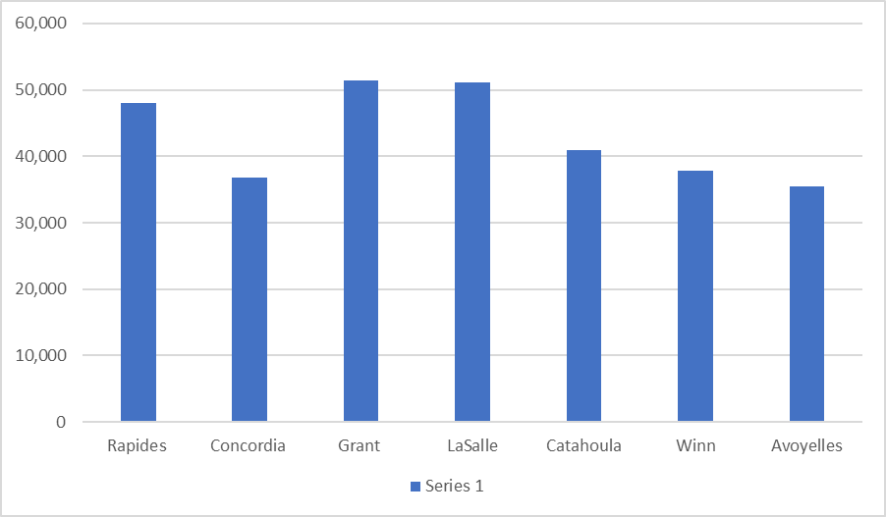

Figure 4 shows the labor force participation rates, for most Region 6 parishes have remained rather stable but still fall below Louisiana’s labor force participation rate. Region 6 has a higher population, age 65 and older (see Figure 3), which could account for the lower participation rate in comparison to the total population.

Figure 4 – State and Region 6 Parishes Labor Force Participation Rates
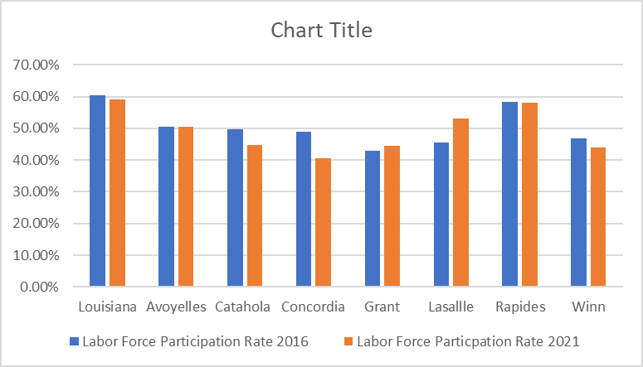
Source: ACS 2016-2021 5 Year Estimates S2301

Table 11 provides information on how genders are represented in the Region 6 workforce. From this study, we find that employed females and males are very closely represented in the civilian labor force in each parish. However, there are a more male unemployed than females in Region 6. Table 11 also reflects that the unemployment rate with both genders has decreased significantly since 2016.

Table 11: Employment Status of the Civilian Labor Force by Parish
 | Labor Force | Employed |  | Unemployed
 | Labor Force | Male | Female | Male | Female
Avoyelles | 16,228 | 8,156 | 8,072 | 654 | 651
Catahoula | 3,066 | 1,377 | 1,391 | 226 | 72
Concordia | 6,159 | 2,471 | 2,928 | 501 | 259
Grant | 8,098 | 4,329 | 3,387 | 232 | 118
LaSalle | 6,325 | 2,948 | 2,980 | 129 | 268
Rapides | 55,347 | 26,050 | 24,951 | 2,179 | 2,167
Winn | 4,969 | 2,604 | 2,112 | 90 | 163
Source: American Community Survey (ACS) 2021

According to latest study by the U.S. Bureau of Labor Statistics, females could be edging out males in the workforce since females are accepting lower paying jobs and part-time employment.

Education and Skill Levels of the Workforce

Provide an analysis of the education and skill levels of the workforce.

Table 12 highlights the educational achievements of the population of Region 6. This group includes a younger cohort, who may still be in postsecondary education. Educational attainment among 18 to 24-year-olds varies widely at the local levels, reflecting demographics, the strength of regional economies, and dominant sectors in those economies. Over 70% of this population in Region 6 has at least a high school diploma and/or some college, etc.

Table 12: Educational Attainment of the Population Aged 18 to 24 years, Region 6
Population 18 to 24 years | # of Individuals
Less than high school graduate | 2,377
High school graduate (includes equivalency) | 4,145
Some college or Associate’s degree | 2,851
Bachelor’s degree or high | 1,445
Source: 2017-2021 ACS 5-year Survey, S1501

Table 13 highlights the educational attainment of the population in Region 6 aged 25 years or older. This population is more likely to have left the educational system. This information reveals that over 66,976 individuals of this aged population have achieved at least a high school degree/equivalency or higher educational attainment. It also shows that over 20,000 individuals have attained their bachelor’s degree in Region 6.

Table 13: Educational Attainment of the Population Aged 25 and over, Region 6
Population 25 years and over | # of Individuals
Less than high school graduate | 18,293
High school graduate (includes equivalency) | 66,976
Some college or Associate’s degree | 33,251
Bachelor’s degree | 20,355
Source: 2017-2021 ACS 5-year Survey, S1501

Table 14 reveals the youth drop-out rate in Region 6. Several parishes have improved the drop-out rates in grades 9-12 over a 5-year period. The youth population leaving the educational system before achieving a high school diploma, or the equivalent, will be unprepared to gain self-sufficient employment without adequate secondary and post-secondary training. However, as dropouts, they might be eligible for services provided under WIOA funding as an Out of School Youth. Youth outreach efforts continue in Region 6 to try to help ensure that these young people are prepared for the workforce and the future.

Table 14: Region 6 School Drop-Out Rate, by Parish Grades 9-12
Parish | 2016-2017 | 2017-2018 | 2018-2019 | 2019-2020 | 2020-2021 | Difference 2016-2021
Avoyelles | 34 | 54 | 18 | 13 | 7 | -27
Catahoula | 3 | 5 | 3 | 15 | 4 | 1
Concordia | 17 | 18 | 28 | 33 | 15 | -2
Grant | 26 | 3 | 2 | 3 | 2 | -24
LaSalle | 0 | 2 | 1 | 2 | 1 | 1
Rapides | 371 | 283 | 217 | 188 | 158 | -218
Winn | 19 | 16 | 11 | 10 | 16 | -3
Source: Louisiana Dept. of Education, Louisiana Believes

Of the civilian non-institutionalized residents aged 18 to 64 years of Region 6, 16% of the population live with one or more disabilities. Residents with disabilities account for 15% of the unemployed and 8% of the employed population; 34% of those not in the labor force have at least one disability. Table 15 highlights the populations with disabilities that are in the labor force. Disability characteristics are not mutually exclusive, meaning one individual may have multiple disabilities.

Table 15: Employment Status by Disability Status, Population Aged 18 to 64 in Region 6
Disability Characteristic | In Labor Force |  |  |  | Not in Labor Force
Disability Characteristic | Employed |  | Unemployed
 | Disability | No Disability | Disability | No Disability | Disability | No Disability
Avoyelles | 1,900 | 12,813 | 140 | 944 | 2,486 | 4,270
Catahoula | 144 | 3,279 | 23 | 190 | 499 | 1,138
Concordia | 270 | 5,926 | 28 | 651 | 785 | 2,545
Grant | 438 | 6,487 | 79 | 543 | 1,073 | 2,525
LaSalle | 338 | 4,236 | 23 | 288 | 808 | 2,188
Rapides | 3,364 | 46,584 | 640 | 3,761 | 8,144 | 14,532
Winn | 321 | 4,160 | 62 | 249 | 953 | 1,655
Source: 2013-2017 American Community Survey 5-Yr, Employment Status by Disability C18120

Table 16 shows the labor force status of the veterans in Region 6 aged 18 to 64 years. Veterans in the region have a fairly high labor force participation rate, with over 65% of those aged 18 to 64 being a part of the labor force. Veterans account for 5.08% of the region’s population.

Table 16: Labor Force Status of Veterans Aged 18 to 64, Region 6
Labor Force Status | Percent
Population | 5.08%
Labor Force Participation rate | 65.39%
Employed | 87.09%
Unemployed | 2.61%
Not in Labor Force | 34.61%
Source: 2021 ACS 5-year Survey, B21005

Skill Gaps

The skills gap is a complex issue, with much disagreement about causes and solutions. Here are some factors experts have identified:

- Not enough of the right graduates: For in-demand jobs in health care, engineering, computer science, and advanced manufacturing, there are not enough people being trained.
- Poor yields from automated job match programs: Some employers fill job ads with a list of ideal requirements most applicants will not meet, resulting in low match rates and few potential candidates.
- Reluctance to provide training: Many employers would prefer that job seekers and employees provide all their own training, but this is increasingly unrealistic.
- Inadequate compensation. Some organizations cannot find candidates because the pay they offer, especially for in-demand jobs, is not competitive with other employers in their area.
- The growing need for soft skills: Many new graduates, while tech-savvy, lack basic communication skills and other critical soft skills.
(Source: CareerOneStop.org/Business center)

The following Table 17 shows the number of completers from Louisiana’s public postsecondary education programs by degree level. Academic years 2014 through 2018 are included. The academic years are labeled by the year in which they begin, so 2018 is the school year beginning in June 2018 and ending in May 2019.

This is compares to the number of annual openings in Region 6 from LWC’s long-term projections, which provides an approximation of what skill levels may show gaps in the future.

Table 17: Public Postsecondary Education Program Completers by Degree Level with Projected Annual Openings
Degree Level | 2014 | 2015 | 2016 | 2017 | 2018 | Annual Projected Openings
Some Postsecondary. No Degree | 9,250 | 9,268 | 8,802 | 9,232 | 8,881 | 2,750
Associate Degree | 5,788 | 6,183 | 5,800 | 5,662 | 5,961 | 600
Baccalaureate Degree | 18,296 | 18,516 | 18,973 | 18,725 | 19,532 | 840
Graduate or Professional Degree | 6,707 | 6,918 | 6,997 | 7,150 | 8,037 | 210
Source: Louisiana board of Regents Degrees and Certificates Awarded by Degree, Degree Level, Gender, Race and Citizenship. Annual Projected Openings from LWC’s Long Term Occupational Projections.

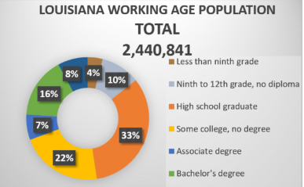
By mid-2020, approximately 53% of open jobs in Louisiana will require a career credential or college degree according to the Georgetown University Center on Education and Workforce. It will take a comprehensive approach to address the challenges the State faces in meeting this expectation. Filling these college-trained jobs will prove challenging to Louisiana’s under-educated adult population.

According to the National Center for Higher Education Management (NCHEMS), Louisiana ranks 49th in educational attainment with only 30.7% of working-aged residents, 25-64 years, earning an associate degree or higher. Table 19 is a further breakdown, for Region 6 of degrees awarded by occupational category. The same comparison is drawn between 2017 graduates and annual projected job openings in Region 6 through 2026
Table 18: Public Postsecondary Education Program Completers by Occupational Group with Projected Annual Openings
Degree Category | 2017 Completers | Annual Projected Openings
Medical | 1,337 | 520
Construction | 688 | 450
IT | 237 | 20
Source: Louisiana board of Regents Degrees and Certificates Awarded by Degree, Degree Level, Gender, Race and Citizenship. Annual Projected Openings from LWC’s Long Term Occupational Projections.

Region 6 has numerous occupations with favorable demand projections (a star rating of 3, 4 or 5) and high base year employment (employment greater than or equal to 500). Table 20 below shows the start ratings, ten-year growth, and education levels required of each occupation.

Table 19: High Employment, High Demand Occupations in Region 6
RLMA 6: Avoyelles, Catahoula, Concordia, Grant, LaSalle, Rapides, & Winn
Star Rating | Occupational Title | 2021 Estimate | 2023 Projection | 2 Year Growth | Education
***** | Registered Nurses | 2566 | 2656 | 90 | Bachelor's degree
***** | First-Line Supervisors of Construction Trades and Extraction Workers | 685 | 756 | 71 | High school diploma or equivalent
***** | General and Operations Managers | 1050 | 1108 | 58 | Bachelor's degree
***** | Nurse Practitioners | 226 | 254 | 28 | Master's degree
***** | Construction Managers | 190 | 215 | 25 | Bachelor's degree
***** | Medical and Health Services Managers | 313 | 337 | 24 | Bachelor's degree
***** | Accountants and Auditors | 470 | 492 | 22 | Bachelor's degree
***** | Lawyers | 234 | 251 | 17 | Doctoral or professional degree
***** | Financial Managers | 216 | 229 | 13 | Bachelor's degree
***** | First-Line Supervisors of Production and Operating Workers | 336 | 347 | 11 | High school diploma or equivalent
***** | Respiratory Therapists | 174 | 184 | 10 | Associate degree
***** | Human Resources Specialists | 205 | 214 | 9 | Bachelor's degree
***** | Physical Therapists | 192 | 201 | 9 | Doctoral or professional degree
***** | Electrical and Electronics Repairers, Commercial and Industrial Equipment | 93 | 101 | 8 | Postsecondary non-degree award
***** | Physical Therapist Assistants | 73 | 80 | 7 | Associate degree
***** | Sales Managers | 112 | 118 | 6 | Bachelor's degree
***** | Pharmacists | 258 | 264 | 6 | Doctoral or professional degree
***** | Management Analysts | 61 | 66 | 5 | Bachelor's degree
***** | Speech-Language Pathologists | 58 | 63 | 5 | Master's degree
***** | Occupational Therapists | 89 | 93 | 4 | Master's degree
***** | Industrial Production Managers | 67 | 70 | 3 | Bachelor's degree
***** | Civil Engineers | 42 | 45 | 3 | Bachelor's degree
***** | Electrical Engineers | 35 | 37 | 2 | Bachelor's degree
***** | Mechanical Engineers | 23 | 25 | 2 | Bachelor's degree
***** | Physician Assistants | 27 | 29 | 2 | Master's degree
***** | Diagnostic Medical Sonographers | 57 | 59 | 2 | Associate degree

The growth of the labor force is constrained by the growth rate of the population. As depicted in Figure 5, age group 55-64, is a significant part of, not only Region 6, but Louisiana’s overall population. With many in this age group moving toward retirement over the next 10 years, the Baby Boomer effect will have a significant impact on the state and region’s workforce. The workforce, however, will remain steady and will balance with the high population of age 15-24, achieving various levels of education (i.e., diplomas, certificates, college degree) and entering the workforce full-time.

As you can see in Figure 5, Region 6 clearly has a higher percentage of the population than the state of those in the “prime working years”, the age group between 25-34 years. LWDA 61 has a higher percentage of youth aged 5-14, persons aged 25-34, and persons aged 45-54 than the rest of the region or the state. LWDA 60 has a higher percentage of young adults aged 15-24 than the rest of the region which will account for labor force stability moving forward.

Figure 5 – Population Comparison By Age (Louisiana, Area 60 & 61)
Source: American Community Survey, 2018 Population Estimates
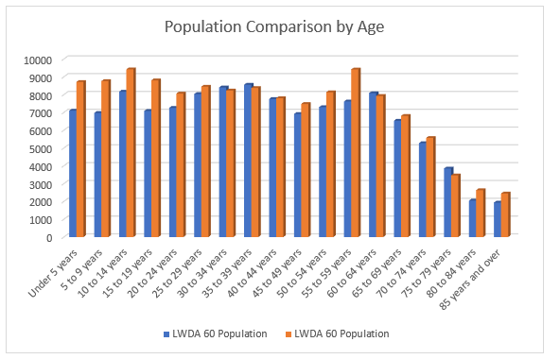
According to the ACS Demographics and Housing Estimates, 2014 American Community Survey 1-Year Estimate, Table 1 shows Region 6 is fairly equalized in race except for the Asian, Native Hawaiian/Other Pacific Islander with a slight variation in numbers of Two or More Races. LWDA 61 has nearly 6 times the Asian population than LWDA 60. With Louisiana’s total Asian population at 96,274, Rapides parish comprises some 2.7% of that total demographic.

Table 20: Race and Hispanic Origin, 2020 | LWDA 60 |  | LWDA 61
Race | # | % | # | %
Total: | 91,742 | 100.00% | 98,792 | 100.00%
White alone | 60,929 | 66.41% | 60,593 | 61.33%
Black or African American alone | 21,126 | 23.03% | 29,008 | 29.36%
American Indian and Alaska Native alone | 617 | 0.67% | 675 | 0.68%
Asian alone | 914 | 1.00% | 1,438 | 1.46%
Native Hawaiian and Other Pacific Islander alone | 38 | 0.04% | 22 | 0.02%
Some Other Race alone | 141 | 0.15% | 298 | 0.30%
Population of two or more races: | 2,407 | 2.62% | 3,316 | 3.36%
Hispanic or Latino | 5,570 | 6.07% | 3,442 | 3.48%
Source: ACS Demographics/US Census Bureau

Employment and Unemployment
Figure 6: Total Nonfarm Employment, Not-Seasonally Adjusted, Alexandria Region (January 2021-June 2022)

The Alexandria MSA’s seasonally adjusted nonfarm employment increased by 2,800 jobs between January of 2021 and June of 2022, a 4.42% increase.
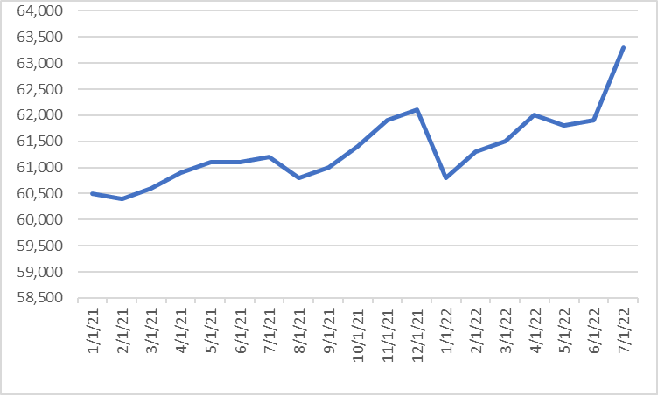
Source: FRED Economic Data-St. Louis FED

Figure 7: Not-Seasonally Adjusted, Unemployment Rate in Louisiana and Alexandria Region (January 2020-December 2022)
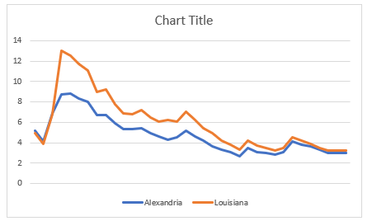
Source: FRED Economic Data-St. Louis FED

Figure 8: Over the Year Change in Total Nonfarm and Private Sector Jobs, Not-Seasonally Adjusted, Alexandria Region (January 2018 – January 2020)

Source: Labor Force data produced by the Local Area Unemployment Statistics (LAUS) Program.

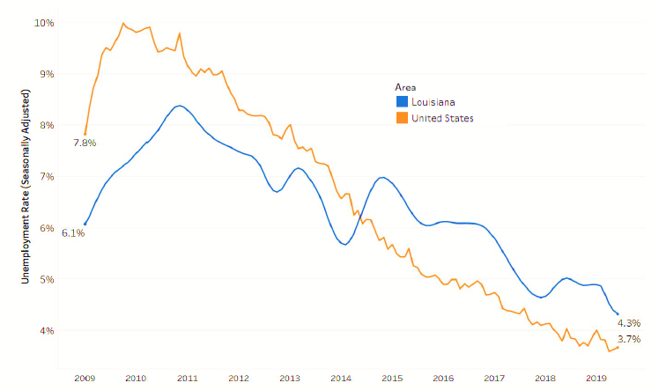
Figure 9: United States and Louisiana Employed to Unemployed Ratio, January 2009 to June 2019

Source: Labor Force data produced by the Local Area Unemployment Statistics (LAUS) and Current Population Survey (CPS) Programs

Between January 2009 and June 2019 Louisiana’s unemployment decreased from 6.1 to 4.3
percent. During this time, the number of unemployed persons decreased from 126,727 to 90,492 and the civilian labor force increased from 2,088,301 to 2,097,545.

Development and implementation of sector initiatives for in-demand industry sectors and occupations
Building Sector Partnerships

We continue to strengthen our industry sector partnership(s) through our regional / local industry by creating career pathways such as manufacturing, healthcare, and Information Technology. Our workforce partners will convene employers, foundations, and regional intuitions by recruiting based on high demand and available job markets, while also assisting with funding for training development and work-based learning. Region 6 will also convene foundations and regional intuitions by collaborating to advance workforce development.

Our established and active industry sector partnerships center around manufacturing, healthcare, and Information Technology.

Other than the active industry sector partnerships listed above, there are currently no other sector-based partnerships in Region 6.

Using LWC’s “Pillar Approach,” which focuses on maintaining relationships with sector and business partners, and to continue to foster an environment for ongoing and progressive training, Region 6 continues to nurture and engage our industry sector partners. These sector partnerships are vital to achieve the commitment needed to the comprehensive implementation of career pathways for jobseekers and employers in central Louisiana. Using this approach mirrors LWC’s vision to span WIOA options and create opportunities to upskill employees. Our region’s workforce staff work to advance these initiatives to vet and build a bridge between jobseekers and in-demand industry and business sector occupations.

Region 6 has integrated Jump Start, a statewide and regionally coordinated dual enrollment program. The Workforce Development Boards continue to provide guidance, recommendations and approval for the targeted demand occupations and training programs that would be most effective in filling regional skill gaps.

Another example of building upon the partnerships within the region includes the start of sharing staff and multiple cooperative endeavor agreements between Economic Development and the Workforce Development Boards. In one example, the partnership results in a neutral convener with additional capacity to help establish sector partnerships. The planning work done by the group is helping to lead opportunities to validate data points to add relevance, create a circle of continuous feedback from industry, identify potential sector initiatives and to grow the economy.

CHAPTER 2: STRATEGIES FOR SERVICE INTEGRATION – REGIONAL COMPONENT

Commitment to Training:

The region has continuously improved its ratio of funding spent on training and supportive services. This has been a tremendous effort to maximize the most efficient methods for delivering high quality services.

PY 2021Training/Work Experience Expenditures
Area | ITA’s | OJT’s | WE | Adult $ | DW $ | Youth $
60 | 113 | 70 | 69 | $685,712 | $176,229 | $233,671
61 | 55 | 1 | 20 | $283,743 | $8,808 | 502,542
Source: HiRE PY2021 Services to Individuals Report and Local Area Reporting

Individual Training Accounts continue to be specifically targeted to assist participants maximize their earning potential in a career field of their choosing. This is not an exhaustive list but is a broad sampling.
Business Administration | Human Resources | Radiology Technician
CDL Class A & B | Licensed Practical Nurse | Education
Engineering | Medical Assistant | Welding Technology
Certified Nursing Assistant | Pharmacy Technician | IBEW
Emergency Medical Technician | Information Technician 4 | Registered Nurse
Machine Operator | Patient Care Technician | Forest Technology
Industrial Technology

Employer-Based Training is an area where the region will continue to work toward increasing opportunities. In a statewide study, 92.4% of those that complete On-the-Job Training (OJT) are still retained on the job after 12 months. The region works together to ensure a seamless process for employers by employing MOU’s to serve regional employers whenever necessary.

Registered Apprenticeships are a growing trend for which the region definitively sees value in promoting and supporting. Programs, such as the Electrical Apprenticeship Program, have grown in recent years. LWC has developed pre-screening tools for all existing regional and local apprenticeship initiatives to assist in expediting the review of applicants funding eligibility whenever needed.

Our Adult Education partner, Central Louisiana Technical College, works in close coordination with their respective local areas to conduct the heavy lift of closing the education gap for many of our adult citizens. Interactive kiosks have been installed in all the comprehensive centers.

Veterans and Disability Services are available by appointment to assist the Centers serving their Veteran clients, informing partner staff, and collaborating to better serve the veteran job seekers. Additionally, there are opportunities for targeted workshops and career fairs to better serve these special and unique populations and to bring awareness to businesses of the benefits of hiring special populations.

Ex-offenders are being better served through multiple initiatives, including the Re-entry Courts, Drug Courts, Day Reporting Centers, and others. There has been the rebranding of ex-offenders to Previously Incarcerated and employers as Second Chance Employers. Significant efforts have been made to identify and educate employers about the benefits of hiring this special population. Additional support for this population includes, committed WIOA funding for Transitional Jobs, career services, connection to partners providing wrap-around services. These expanded partnerships have led to WIOA staff co-location in some prisons and parole centers and creating a pathway for the build-out of the State Reentry program under the Second Chance Act. These efforts have resulted in more effective coordination with prison transitional case managers.

Adult, Dislocated Worker and Youth

WIOA called for the elimination of “sequence of service” provision in Title I programs in accordance with a more integrated service delivery model across partner programs. The new model connects partners to clients at any entry point where assessment occurs. The process is further driven by co-enrollment across all active partner programs, as appropriate. The process modification allows for a more holistic approach to serving these populations offering more comprehensive, individualized, and seamless services.

Strengths and Weaknesses of Workforce Development Activities
(Highlighted sections below are in response to updates requested by LWC; 5/21/2022)
Strengths | Weaknesses
Both LWDAs have good working relationships with their required and optional partners. Both LWDAs act regionally and collaborate with each other on a frequent basis. | - Most of the public still thinks we are the unemployment office.  - Perception is the battle as most in the community do not know what we do or the services we can provide.  - The lack of a consistent marketing campaign has diminished our ability to develop and keep relationships with job seekers and employers.  - Limited funding for advertising and marketing the services of the American Job Centers.
Title 1 performance goals are the primary focus for our region with staff willing to meet the challenge of serving the people of our area. | - Additional training opportunities for staff  - LWDAs are not always able to meet the needs of individuals with barriers, often due to employability skills or “soft skills.” For employers, these foundational skills are the key to job-readiness.  - Employees/case managers are limited in finding low or no cost resources to teach/improve these essential skills.
Both LWDAs have exceptionally skilled and experienced staff that are trained to assist our customers. | - More cross-training within the regions and with our partners is much needed.
Both LWDAs are working to be more creative with program design and implementation to increase productivity. | - Budgetary realities and restrictions, combined with the refocus and expansion of services under WIOA, have required our area to reassess and reconfigure staffing to ensure that there is a depth of resources and coverage available for all programs.
There are excellent institutions for post-secondary training in the region. I.e., colleges, vocational/technical, and certificate/licensing. | Most of the post-secondary institutions are located in one parish of the region and public transportation is limited to metro areas
There are a lot of experienced workers in ‘career jobs’ in Region 6. | - Obsolete and “mismatched” skills / education of workers vs. the needs of existing open positions and projected industry needs.
This region has a large population of youth to take over jobs as Baby Boomers retire. | - Elevated levels of unemployment for Region 6 youth. We also have a significant number of dropouts in the region.  - Employer engagement and involvement in training a new workforce, work experiences, OJTs, etc.  - Employers will be losing tremendous depth of knowledge if younger workers are not hired and do not learn from more experienced workers.
Business Services has made significant inroads into market penetration in the region | Small employers usually employ dated practices and have limited awareness of how to strategically anticipate their future workforce needs. Good temporary staff are lost due to lack of permanent employment opportunities.
Workforce programs and funding are provided by the state and federal government to help employers up skill their current workers. | Many employers continue to be unaware of these programs.

Additional specifics regarding operations and service delivery to all the aforementioned initiatives are further detailed in the regional strategies section, as well as the local area portions of this combined regional plan.

Partner Agencies
Region Six is the largest workforce region in the state with four LWDA designations. There are currently 72 entities that account for the mandated partner agencies that work in close collaboration and coordination of direct and complimentary service delivery. There are MOU’s in place with required partners and that list continues to expand as we all seek to ensure the most effective and efficient means of serving the community, in particular, special populations and the hardest to serve.

LWDA 60: Sixth Planning District
Table 23: LWDA 60 One-Stop Partners, Roles, and Resource Contributions
PARTNERS | ROLE / RESOURCE CONTRIBUTION | FT/PT?
Louisiana Workforce Commission | Wagner-Peyser Employment Services: Employment Service focuses on providing a variety of services including job search assistance, help getting a job referral, and placement assistance for job seekers.  Unemployment Insurance services: services to help jobseekers who are experiencing unemployment to access benefits and resolve issues while assisting with job search, etc.  Reemployment Services and Eligibility Assessment (RESEA): Re-Employment Services and Eligibility Assessment (RESEA) Program is to help Unemployment Insurance (UI) claimants return to work faster through personal case management and job matching.  TAA: The Trade Adjustment Assistance program provides services to workers who lose their jobs or whose hours of work and wages are reduced because of international  competition. TAA services, which are offered at no cost, may include training awards, job search and relocation allowances, income support and health coverage tax credits.  Veteran services provide employment assistance and training opportunities to Veterans and other eligible individuals, mainly job assistance, job and training referral and job placement. | Full-time
Louisiana Rehabilitation Services | Employment and Training Services under the Rehabilitation Act and WIOA  LRS provides printed informational materials and staff, as needed, to assist in providing services to eligible customers. | Part-time
LWDA60 Workforce Operations Dept.  LCAA, Inc. One Stop Operator | Adult services  Dislocated Worker services  Youth services | Full-time
LWDA60 Workforce Development Board | Provide oversight of the Workforce Development system and One-Stop Operator | Full-time
CSBG | Provides receptionist staff assistance and provides services through the Community Services Block Grant, including energy and housing assistance | Full-time
Dept. of Children and Family Services | Temporary Assistance for Needy Families (TANF)  Supplemental Nutrition Assistance Program (SNAP) | Part-time
Area Agency on Aging  AYUDA & SCEP | Title V Senior Community Services Employment Program, provides reception staff, who is also cross trained to assist customers in accessing HiRE | Part-time
Central Louisiana Technical College | Title II Adult Education  Career and Technical Education | Part-time
National Farmworker Jobs Program | Referral system in place for those customers | Part-time
Hud Employment and Training | Referral system in place for those customers | Part-time

LWDA 61: Rapides
Table 22: LWDA 61 One-Stop Partners, Roles, and Resource Contributions
PARTNERS | ROLE / RESOURCE CONTRIBUTION | FT/PT
Louisiana Workforce Commission | Wagner-Peyser Employment Services: Employment Service focuses on providing a variety of services including job search assistance, help getting a job referral, and placement assistance for job seekers.  Unemployment Insurance services: services to help jobseekers who are experiencing unemployment to access benefits and resolve issues while assisting with job search, etc.  Reemployment Services and Eligibility Assessment (RESEA): Re-Employment Services and Eligibility Assessment (RESEA) Program is to help Unemployment Insurance (UI) claimants return to work faster through personal case management and job matching.  TAA: The Trade Adjustment Assistance program provides services to workers who lose their jobs or whose hours of work and wages are reduced because of international competition. TAA services, which are offered at no cost, may include training awards, job search and relocation allowances, income support and health coverage tax credits | Full-time
Louisiana Rehabilitation Services | Employment and Training Services under the Rehabilitation Act and WIOA  Ticket to Work  Provides comprehensive rehabilitation services that go far beyond those found in routine job training programs. LRS offers individuals with disabilities a wide range of services designed to provide them with the skills, resources, attitudes, and expectations needed to compete in the interview process, get the job, keep the job, and develop a lifetime career. | Part-time
Central Louisiana Technical Community College | Title II Adult Education  Career and Technical Education | Part-time
Rapides Workforce Development Board | Policies and oversight of the One-Stop Operator | Full-time
Jobs for Veterans State Grants (JCSG) | Provides individualized career and training-related services to veterans and eligible persons with significant barriers to employment and to assist employers fill their workforce needs with job-seeking veterans.  Veteran services provide employment assistance and training opportunities to Veterans and other eligible individuals, mainly job assistance, job and training referral and job placement. | Full-time
Rapides Parish – Ofc. of Economic & Workforce Development | Fiscal and programmatic oversight of workforce development programs within the One-Stop Centers | Full-time
Cenla Community Action Committee, Inc. | Community Services Block Grant: provides supportive services to help low-income individuals become or remain self-sufficient. Each agency offers a range of services which can include assistance with transportation, housing, income management, energy costs, nutrition, health care, emergency food and shelter, employment, and training. | Full-time
Dept. of Children and Family Services | Temporary Assistance for Needy Families (TANF)  Supplemental Nutrition Assistance Program (SNAP) | Full-time
Rapides Parish School Board | Jump Start Initiative: Program prepares students to lead productive adult lives, with the option to continue their education and training after high school in addition to earning certifications that will create a pathway to prosperity upon graduation.  PK – 12: teaching prekindergarten to grade 12 students in a school that is accessible to all or most people | Not located in Center. A community partnership.
Area Agency on Aging  AYUDA & SCEP | Title V Senior Community Services Employment Program, provides reception staff, who is also cross trained to assist customers in accessing HiRE | Part-time
Job Corps | Employment and Training Services | Part-time
Hud Employment and Training | Referral system in place for those customers | Part-time

Transportation and other Supportive Services Coordination

Regional organizations that currently could provide supportive services are:
- Louisiana Rehabilitation Services/DSS
- Louisiana Department of Education
- The Salvation Army
- Trade Adjustment Assistance
- Department of Children and Family Services
- Office Veteran Affairs

Region 6 has policies and procedures that have been established to promote supportive service delivery. Supportive services are carefully coordinated locally between partners to ensure maximum availability to the community and avoidance of duplication of services. Supportive services that are available from the partners are in accordance with each partner’s mandates, regulations, local policies, and funding availability. Examples of supportive services that are available within the region include:
• Transportation assistance
• Housing assistance
• Utilities assistance
• Food security assistance
• Training assistance: books, supplies, fees, tools, uniforms
• Childcare assistance
• Needs-related payments
• Other supportive services defined by the individual need to participate in the workforce or in training.

Local workforce areas incorporate into their local policies the verification of supportive services that are available in the local area at the time of each individual request for such funded services as they are frequently subject to change due to funding availability.

Coordination of services with regional Economic Development
Economic development organizations, WOIA service providers, and businesses who are actively engaged within our region are; The Rapides Foundation, Louisiana Economic Development District, LWDB 60 and 61, Chambers of Commerce, and Community Action Agencies.
Currently, in Region 6, there are no economic development organizations, WOIA service providers, or businesses who were invited to participate and declined.

Sector strategy initiatives have been developed, by LWC, in each of the 8 Workforce Regions of the state. LWC has industry coordinators and business consultants currently on staff and assigned to each region. Their primary roles are to engage business and industry to identify short- and long-term workforce needs and assist local workforce boards (business consultants) and One-Stop Centers (industry coordinators) with developing goals, objectives, and strategies to address these needs.

CHAPTER 3: VISION, GOALS, AND IMPLEMENTATION STRATEGIES – REGIONAL COMPONENT

Regional Strategic Vision and Goals
The Unified or Combined State Plan must include the region’s strategic \for developing its workforce and meeting employer needs in order to support economic growth and economic self-sufficiency. They must include:

- VISION
Describe the region’s strategic vision for its workforce development system.

The only way the LWDBs that make up Region 6 and Louisiana will have a successful workforce development system is to subscribe to the same vision and goals as the Louisiana Workforce Commission. Therefore, our regional vision is:

Region 6 envisions a workforce system that will provide pathways for all people of Louisiana, including individuals receiving public assistance, the unemployed or underemployed, those deficient in basic skills, persons with disabilities, including disabled veterans, and others who have significant barriers to employment. All will have access to education, training, and supportive services needed to prepare for and secure high-demand occupations that pay family-sustaining wages.

Industries that once required their entry-level workers to have only a high school diploma are increasingly requiring that their workers also have specialized occupational skills. Sector strategies are integrated into Region 6’s approach that aims to help workers obtain these skills through targeted training programs and other services developed in direct response to employer demand. Research completed by the Federal Department of Labor (dol.gov) has shown that sector strategies can increase earnings and improve job quality for the under-skilled workforce. Further, businesses that have participated in sector strategies have credited the initiatives with increasing their productivity and reducing their operating costs.

Region 6 strategic vision seeks to support job seekers and employers, alike, to create a strong, vibrant, and inclusive economy in all 7 parishes of the region. By strengthening our diverse partnership with employer groups, allied workforce efforts, and education and training providers, we work to create the necessary conditions for moving all job seekers to high quality and sustained employment.

- GOALS

Describe the goals for achieving this vision based on the analysis in (a) above of the regional’s economic conditions, workforce, and workforce development activities. This must include -

      - Goals for preparing an educated and skilled workforce, including preparing youth and individuals with barriers to employment and other populations.
      - Goals for meeting the skilled workforce needs of employers.

Goal 1: Continue to strengthen existing and establish Career Pathways as a model for skill, credential, and degree attainment for Louisiana citizens to secure jobs that provide opportunities for economic independence and family stability. This goal will be accomplished by executing the following objectives:
- Workforce development system partners are continuing to collaborate to develop a shared vision and strategy for industry sector-based career pathways for youth and adults.
- Engage employers and integrate sector strategy principles to ensure multiple employers, business associations and organized labor are partners in creating demand-driven career pathways.
- Increase the identification, prioritization, and leverage of workforce system partner resources.
- Strengthen the alignment of Jump Start, WorkReady U, and other viable initiatives as entry and exit points in the career pathways.
- Expand utilization of registered apprenticeships by industry sector.

Goal 2: Expand career services and opportunities for populations facing multiple barriers to close the gap in educational attainment and economic advancement through career pathways.
- Using regional, sector-based career pathways, link low-skill job seekers to take advantage of educational opportunities and bridge programs to obtain middle-skill jobs for those with educational barriers.
- Continue to work with local resources (i.e., Reentry Solutions, Department of Corrections) and partners to reduce recidivism in returning citizens.
- Efforts related to this goal include the provision of more work-based learning opportunities, access to in-demand industry certifications, job readiness training, and relevant skill building efforts.

Goal 3: Increase the participation and utilization of the workforce system by employers and jobseekers.
- Foster the improvement and expansion of employer-driven regional sector partnerships to meet occupational demands as supported by regional labor market information.
- Increase the use of labor market and educational data / technology, in coordination with local data, to inform and guide strategic workforce development decisions.
- Develop focused, regional workforce initiatives that blend partner resources (co-. investment) to educate and train workers.
- Educate and resource training for workers for high-demand jobs within the workforce region.
- Increase the alignment and efficacy of formula, discretionary and competitive workforce funding to support regional and local workforce initiatives.
- Promote meaningful portable industry credentials for experienced workers.

- PERFORMANCE GOALS

The proposed performance goals for the region / local areas are listed in Appendix 1.

In addition to the common performance measures, Region 6 tracks business-focused metrics as well. This helps to identify standardized indicators for measuring effectiveness in serving employers. The primary source of information for this measure is data recorded in the MIS system of the Louisiana Workforce Commission, HiRE. Services to employers are both automatically recorded by HiRE and manually entered into HiRE by One-Stop Center staff.

- ASSESSMENT

Describe how the Region will assess the overall effectiveness of the workforce development system in LWDA 60 & 61 relation to the strategic vision and goals stated above and how it will use the results of this assessment and other feedback to make continuous or quality improvements.

In Region 6, our LWDB’s focus is on the identification of opportunities met and those opportunities for improvement. We are fortunate in having a highly qualified staff with demonstrated performance in the provision of multi-level assistance to employers and jobseekers.

Quarterly review and assessment of WIOA programs is conducted to ensure consistency of service, fiscal responsibility with participant success being our focus. This monitoring is conducted to ensure the One-Stop Career Centers are using program funds responsibly, as well as assuring policies and procedures are adhered to by all customer service office staff.

The results of the participant WIOA expenditure reviews are documented and compiled in a written report identifying deficiencies and recommendations for improvement. Upon review and result compilations, the report is distributed to the director and program supervisor. Corrective action is requested on a case-by-case basis. This assessment and review enable customer service staff to measure performance at the case manager level and where improvement might be needed.

Feedback, to our case managers, through this assessment process provides an opportunity for a greater emphasis on customer-focused and effective case management. In providing guidance, support and motivation to customers that seek training, employment, and career advancement, staff take a holistic case management approach that utilizes multiple techniques to address and provide solutions for a variety of barriers and assessed needs of their customers.

While our region enjoys many strengths, we also recognize the importance of implementing continuous improvement efforts that adjust to changing market conditions, as well as the needs of individual job seekers and employers. Therefore, LWDB Directors actively participate in the evaluation and analysis of opportunities for successes.

(c) REGIONAL STRATEGY

The Combined Regional Plan must include the region’s strategies to achieve its strategic vision and goals. These strategies must consider the region’s economic, workforce, and workforce development, education, and training activities and analysis provided in Section (a) above. Include discussion of specific strategies to address the needs of populations provided in Section (a).

- Describe the strategies Region 6 will implement, including industry or sector partnerships related to in-demand industry sectors and occupations and career pathways, as required by WIOA section 101(d)(3)(B), (D). “Career pathway” is defined at WIOA section 3(7) and includes registered apprenticeship. “In-demand industry sector or occupation” is defined at WIOA section 3(23).

Building Sector Partnerships

We continue to strengthen our industry sector partnership(s) through our regional / local industry by creating career pathways such as manufacturing, healthcare, and Information Technology.

Using LWC’s “Pillar Approach,” which focuses on maintaining relationships with sector and business partners to continue to foster an environment for ongoing and progressive training, Region 6 continues to nurture and engage our industry sector partners. These sector partnerships are vital to achieve the commitment needed to the comprehensive implementation of career pathways for jobseekers and employers in central Louisiana. Using this approach mirrors LWC’s vision to span WIOA options and create opportunities to upskill employees. Our region’s workforce staff work to advance these initiatives to vet and build a bridge between jobseekers and in-demand industry and business sector occupations.

Central Louisiana is fortunate to have had strong leadership from economic development agencies, secondary and postsecondary education, workforce development, and industry in the creation of regional career pathways through the DOE’s Jump Start program. This regional Jump Start team has aligned education with the needs of employers and created opportunities for secondary youth to achieve a credential and gain employment immediately upon graduation. The Education Subcommittees of the regional Workforce Development Boards are working with Jump Start to ensure career pathways and educational requirements stay on track with current and future needs.

Regional Business Service Team Framework
A regional Business Service Team within Region 6 consists of the following programs and provides a sector-based approach to a partnership between the LWC, LWDBs, core programs and other partners in the region:
- Wagner-Peyser
- Veterans / LVER
- Adult / Dislocated Worker / youth programs
- Louisiana Rehabilitation Services
- Incumbent Worker Training Program
- Rapid Response
- Other stakeholders and optional community resources

- Strategies used to align the core programs, and Combined Plan partner programs included in this Plan, required and optional one-stop partner programs, and any other resources available to achieve fully integrated customer services consistent with the strategic vision and goals described above. Also describe strategies to strengthen workforce development activities regarding weaknesses identified in section II.

The LWDB 60 and 61 intends to continue efforts toward expanded coordination of service delivery with all partner agencies throughout each year. The goal is to modify and improve partner and local agreements regarding support of the one stop delivery system, identify the service strengths of each agency, and develop an improved inter-agency referral process and co-enrollment linkages across systems through on-going meetings leading to the development and implementation of a comprehensive Memorandum of Understanding (MOU). The MOU’s with each partner will be updated according to changes and modifications to services.

Region 6 workforce teams are working diligently to create a strong integrated network with key agencies and community partners to expand accessibility and wrap-around services for individuals with barriers seeking employment. In developing deeper connections with partnership programs that support these individuals will further promote and simplify efforts to match employment programming more closely to each person in need.

Regions 6 aims to empower and coach our most vulnerable community members and customers through an integrated, cumulative, and agile services continuum, moving from initial engagement through job retention, unique to every person, and resulting in long-term employment that fulfills an individual’s passion, meets financial needs, embodies skill development, and supports well-being.

OPERATIONAL PLANNING ELEMENTS

The Combined Regional Plan must include an Operational Planning Elements section that supports the region’s strategy and the vision described in Section III(c) above. Unless otherwise noted, all Operational Planning Elements apply to Combined Region Plan partner programs included in the plan as well as to core programs. This section must include –

REGIONAL / LOCAL STRATEGY IMPLEMENTATION

      - Describe how the local boards will implement the functions under section 101(d) of WIOA (i.e., provide a description of Board operational structures and decision-making processes to ensure such functions are carried out:

The mission of Region 6, local boards is to support the development of an employer-led, demand-driven workforce development system based on occupational forecasts in which training, education and services for jobseekers prepare the regions residents for high-wage, high-demand career opportunities. LWDBs 60 and 61 will continue to work closely with eligible training providers in central Louisiana to ensure training programs for which WIOA funds are used meet the needs of local job seekers and employers.

Region 6 boards will achieve and be successful in this mission by mirroring the vision of LWC by:

The local boards will meet no less than four times each calendar year, and all meetings comply with the Louisiana Open Meetings Law. Decisions are made by a vote of a majority of the total serving membership of the WIC. Decision-making votes shall be conducted according to Robert’s Rules of Order. Educational and informational portions of meetings are conducted according to the preference of the Chair. The Executive Committee of the local board is comprised of the Chair, Vice Chair, and a sample of heads or designees of agencies represented on the board. The board is composed of a majority of business members. However, local board may include representatives of agencies or entities administering programs serving the local area relating to transportation, housing, and public assistance, representatives of philanthropic organizations serving the local area, and/or other representatives as the Chief Elected Official deems appropriate.

Some of the responsibilities of the local boards include:
- Submitting a strategic plan to meet current and forecasted workforce needs to the state and report plan progress.
- Driving local policy to support the alignment of education and training with workforce demand.
- Supporting the alignment of Jump Start Pathways with statewide and regional workforce demand through the Graduation Pathway Review Panel.
- Negotiate local performance accountability measures as described in Section 116 (c) of the WIOA.
- Coordinate activities with education and training providers in the local area in accordance with WIOA.
- Designate or certify the One-Stop Operator, Youth Provider(s), and other providers of services in accordance with WIOA.
- Develop a budget for the activities of the local board in the local area, consistent with the local plan and the duties of the local board under the WIOA.
- Assess annually the physical and programmatic accessibility for individuals with disabilities of the One-Stop Center in the local area.
- Establish and maintain a comprehensive American Job Center in the local workforce development area of Rapides Parish to provide the services identified in 20 CFR 678.305

  - a. Career services
  - b. Access to training services
  - c. Access to employment and training activities
  - d. Access to programs and activities carried out by one-stop partners
  - e. Workforce and labor market information

LWDB 61 will utilize program evaluation criteria (at least a 30% completion rate, at least a 50% employment rate, and at least an $10 wage rate) as well as the in-demand occupations (i.e., Star Rating System) to determine the programs that should be WIOA approved for the current year. We will follow the LWC Policy, OWD 11-08.1 – Certification Process for Eligible Providers of Training Services, to ensure that training providers offering high quality training services for existing and emerging industries are included on the Statewide Eligible Training Provider list thereby presenting our customer with the best choices for training.

LWDB 60 coordinates and collaborates with eligible training providers to ensure that services are addressing the needs of our employer community. The coordination includes planned meetings to discuss new employer workforce needs (which will include the LWD Board meetings, of which training providers and industry leaders are represented.) Additional meetings will be hosted by LWDB 60 as determined necessary by labor market changes. These meetings, along with Board meetings, may address systematic adjustments needed by one or more partners to ensure employer and jobseeker customers are fully served, both efficiently and effectively.

To collaborate with eligible providers, the Board will utilize the LWC program evaluation criteria (at least a 30% completion rate, at least a 50% employment rate, and at least an $10 wage rate), as well as the in-demand occupations (i.e. Star Rating System) to determine the programs that should be WIOA approved for the current year. We will follow the LWC Policy, OWD 11-08.1 – Certification Process for Eligible Providers of Training Services, to ensure that training providers offering high quality training services for existing and emerging industries are included on the Statewide Eligible Training Provider list thereby presenting our customer with the best choices for training.

LWDB 60 will continue to assess the needs of our employer community, identifying employee gaps, to ensure this information is communicated to our training providers of services and jobseekers. To ensure we have a complete picture of employment needs, we will rely on data collected by LWC’s Occupational Forecasts, our 4 parish economic development organizations and Central Louisiana Economic Development Alliance. We will also collect information on employment needs from local chambers of commerce and other local business organizations. This information will be synthesized and shared with our service providers for training development purposes. Where necessary, training service providers will be encouraged to develop special employer-based, employer-led training to address specific shortages.

Employer needs will also be shared throughout our WIOA offices, to ensure that jobseekers understand the skills and talents required by local and regional employers. For the skills gaps identified, we will work with our training providers to validate the need and develop low-cost avenues for sharing that information with jobseekers. This information will also be shared with less skilled workforce members, to ensure they are afforded opportunities to increase their skills, thus increasing their income.

LWDB 61 engages in regular and consistent communication to assess the needs of business customers and ensure that service delivery is efficient. The Industry Coordinator and Business Services Team maintain regular communication with businesses, industry leaders, and governmental agencies in the Rapides Parish.

In LWDA 61, many of the services provided through the one-stop delivery system are available through our online labor exchange services, HiRE, at www.laworks.net. This online system provides a complete set of employment tools for jobseekers in Louisiana. Jobseekers and employers access jobs, resumes, education, training, and labor market information. Once a jobseeker or employer access HiRE, the system will provide guidance on how to register, identify their skill sets, create a resume(s), and utilize the job search features to look for a job, communicate with employers through message center, and apply for jobs. Labor market information is also available, as is information on occupations and training programs. Additionally, we use social media, Facebook, and Constant Contact, to provide a broad and aggressive communication avenue for job center events and services.

LWDA 60 will facilitate access to services provided through the one-stop delivery system utilizing several methodologies. First, local employers will be encouraged to utilize the HiRE system to post job orders. LWDA 60 staff will help with training, as needed. This step will ensure that jobseekers have access to local employment opportunities.

As all our parishes are rural, and many of the jobseekers are low-income, we will make every effort to reduce transportation barriers to access. Therefore, we will rely on technology and our community partners to bring the services to jobseekers in remote areas. LaSalle Community Action Association offices will serve as available resources for jobseekers in remote areas, as staff have basic training on accessing the HiRE site. LCAA offices will also be available to assist in providing necessary eligibility documents to WIOA office staff in different communities (via fax and email), thus preventing jobseekers in remote areas from expending funds to travel 10 – 25 miles to a LWDA 60 office to deliver paperwork.

LWDA 60 will also utilize social media to connect jobseekers with opportunities. A Facebook account has been developed to advertise regional and local new job announcements, publicize notices for jobs that prove difficult to fill, and advertise job fairs in the local and regional area. We currently have a Facebook page to help connect jobseekers to employment opportunities. This will also be an avenue to publicize activities at the workforce offices. In both instances, jobseekers will be encouraged to connect with LWDA’s account, and to share information with others.

Our Region 6 boards are committed to establishing innovative ways to meet the needs of our employers with limited funding and resources. Forward thinking will create opportunities for local board, directors, and staff to reshape and expand workforce systems, policies, and practices that are grounded in research and experience to improve the education and employability of low-income people and people with barriers to employment. To bring these opportunities to fruition, local boards will utilize the opportunities available through WIOA guidance. These improvements and changes will not happen automatically. WIOA directives are evolving each year and continue to establish new activities and requirements and codifies federal guidance and regulations that already exist. These changes create an opportunity to leverage systemic change across the currently disconnected education and training systems. Our One-Stop System of working with our AJC Partners ensures elimination of duplication of services therefore utilizing limited funding while maximizing effectiveness.

The LWDA 61 is completely focused on complying with Section 188 and the Americans with Disabilities Act (ADA) which prohibits discrimination against people with disabilities in several areas, including employment. As it relates to employment, Title I of the ADA protects the rights of both employees and job seekers. The ADA also establishes requirements for telecommunications relay services. The LWDB 61 staff aid with programs and activities in a manner that makes services readily accessible to qualified individuals with disabilities. Our goals are to ensure staff and program personnel have the education, training, and experience (skill, ability, and knowledge) to perform assigned duties regarding nondiscrimination and quality of opportunity for persons with disabilities. LWDA 61 works closely with program partners, with the major of these being Louisiana Rehabilitation Services, made up of government agencies, community organizations, and private sector employers, to reach our area’s job seekers with disabilities.
The Board believes these actions help ensure that communications with individuals with disabilities are as effective and equal to communications with non-disabled individuals. The Rapides One-Stop has assistive technology items in the One-Stop Center to assist individuals with disabilities to access a computer for the same services available to those without disabilities. The One-Stop staff has been trained to operate the assistive technology. The Rapides One-Stop meets basic ADA requirements for operation.

LWDA 60 recognizes the importance of full compliance with the provisions of the Americans with Disabilities Act of 1990, as well as other applicable state rules. As part of our compliance verification, our designated EEO officer will conduct an annual review of physical and programmatic accessibility of our facilities, programs, and services. The review of facilities will be conducted using the ADA compliance checklist for facilities. All partners in the one-stop will be required to comply with all components of the checklist. This will ensure that Centers are fully accessible to all, and this review is submitted to the LWC’s compliance officer.

Within our centers, we ensure that program staff possesses the skills and knowledge to provide assistance to differently abled individuals. This includes specific knowledge of the operation of each Center’s assistive technology specifically designed for the visually and hearing impaired that includes access to the Language Line, DRAGON, and JAWS software.

(2) Implementation of Regional Strategy.
Describe how the lead State agency with responsibility for the administration of each core program or a Combined State Plan partner program included in this plan will implement the State’s Strategies identified in II(c) above. This must include a description of—
(A) Core Program Activities to Implement Region 6 Strategy. Describe the activities the entities carrying out the respective core programs will implement the Region’s strategies. Also, describe how such activities will be aligned across the core programs and combined.

Regional Plan partner programs included in this plan and among the entities administering the programs, including using co-enrollment and other strategies, as appropriate.

Our local board is committed to working to minimize overhead costs and streamline services for our community. Supporting LWC’s to refocus on employment, training and education, and vocational rehabilitation programs, Region 6, LWDA 61 One-Stop Center and each affiliate One-Stop Center, through a combined infrastructure, strengthens the ability to provide seamless delivery and access to services in the following four (4) ways as defined by LWC’s state plan.

    - Increasing the focus on serving the most vulnerable workers (with limited skills, lack of work experience, and other barriers to economic success) through more focused profiling and assessment processes.
    - Researching education and training options to help participants’ access good jobs to start/advance their careers.
    - Providing targeted, managed, and appropriate levels of supportive services to disadvantaged and unemployed adults and youth while they receive training and effective employment-based activities.
    - Supporting the alignment of planning and accountability policies across core programs to support more unified approaches to serving employers and jobseekers (those who are low-income, low-skilled individuals).

- Implementation: As a minimum, the following details required in WIOA must be crafted into a cost allocation and operation agreement for each of these Comprehensive One-Stop Centers and although they will be specific to the individual LWDA, they must contain detail on the following as a minimum:

- Who will be physically present in the center – full or part-time?
- When not physically present center staff will be required to supply support, i.e., provide
customer guidance when using an online tool, etc.?
- What services will be offered, and how do those services support a Career Pathway?
- Defined interface with partner programs to provide seamless services.
- Method of supervision and guidance provided to staff.
- Defined administrative or other support required to be successful.
- Facility costs.
- Operational delivery, how services are delivered, by whom and when.

Cross-Program Strategies

As part of the region’s approach to further integrate a stronger cross-program strategy that meets the needs of the various populations and sub populations, we seek opportunities to enhance services to best serve those individuals. Some of these strategies include:
- Priority of service has been set for adult training funds to serve low income individuals
- An integral partner in work/training requirements of SNAP and TANF recipients.
- Region-wide assistance and coordination to serve the ex-offender special population
- Strong commitment to serve youth in various summer youth training and employment programs that co-mingled and leverage local and federal funds
- Region-wide comprehensive re-employment efforts for those that are receiving unemployment insurance and have been profiled as likely to exhaust benefits.
- Support for all State initiatives to strengthen services to persons with disabilities and Veterans. Veterans’ reps are fully integrated into the one-stop operations.
- Proactive regional approach to Rapid Response efforts, including intensive services for the workers impacted by lay-offs, providing joint orientations, joint coordination of specialized recruitment events, etc.
- Improved Adult Education collaboration and workforce coordination with the eleven entities engaged in those activities, as further detailed above

Cross-regional Stakeholder Partnerships:
- Expanded partnerships include numerous industry associations, such as Home Builder Association, Louisiana Restaurant Association, New Orleans Society for Human Resource Management, Northshore Society for Human Resource Management, and, to name a few.
- Improved economic development organization collaborations, including New Orleans Business Alliance, Regional Planning Commission, Greater New Orleans, Inc., St. Tammany Corporation, JEDCO, to name a few.
- Expanded relationships with the Louisiana Small Business Development Center, Greater New Orleans Data Center, and the Literacy Alliance.

Leveraging and Aligning Resources

In times of competing demands upon limited resources, not only is leveraging resources vital to success and sustainability, so are efforts to increase the flow of resources to the region. The region has developed a systematic approach to applying for grants that will benefit the region. We will continue to seek out opportunities to leverage financial resources of stakeholder partners, such as the contracts to share in the cost of data access with the Regional Planning Commission and Greater New Orleans, Inc., and numerous co-location efforts. All funding opportunities that are aligned with and that promote regional goals and activities continue to be heavily investigated. Additionally, concepts for self-generated revenue continue to be explored to off-set future budgetary funding cuts and shortfalls.

The region also supports efforts being made by the Louisiana Workforce Commission to assist in facilitating the shared financial resources for mandated One-Stop Partners as it related to service delivery. Additionally, the region supports moving funds from TAA and IWTP to the local areas to serve businesses and jobseekers more directly as a pilot program.

Leveraging resources extends to the sharing of regional administrative and program costs, such as the development of a regional outreach piece. The region continues to share in the costs and management of regional projects where necessary and will begin to explore additional opportunities for sharing administrative and program costs in areas where most appropriate via an exploratory committee.

Regional Policy Alignment

Region Six continues to embrace the commitment toward policy alignment to streamline the workforce development system to better serve businesses and jobseekers, where appropriate. This approach supports a regionally based, integrated, employer-driven workforce development model that will ensure faster, more comprehensive, and more effective systematic and substantive transformation that supports the Governor’s vision.

Some examples of policy alignment efforts include discussions of Regional processes for:
- On-the-Job Training processes and employer contracts
- Funding caps for Individual Training Accounts (ITA)
- Applying for and supporting local, regional, and partner grant applications
- Rapid Response efforts
- Regional Career Fair events
- Shared Professional development.
The region can advance policy alignment efforts because of the ongoing and productive joint planning and communication that, under normal circumstances, is regularly held between the WDB Directors in the region.

Conclusion of Regional Portion

The Workforce Development Board Partnership continues to exhibit a unique strength and ability to be responsive and proactive to the changing economic times of the eight parishes that are represented in Region 6. The four Boards will not only continue to strive for excellence individually, but also serve as an incubator for workforce development innovation. We look forward to overcoming challenges and advancing the region to serve as a model for the State and in the nation.

Attachments:
Region Six– Local Workforce Development Area Plans

LWDA 60 Six Planning District Local Plan & Attachments
LWDA 61: Rapides Local Plan & Attachments

